AGSUP_ENDURANCE_THROUGHPUT_SUITE

Job Link: http://jenkinsqant1:8080/view/Performance/job/AGSUP_ENDURANCE_THROUGHPUT_SUITE/

Desc:
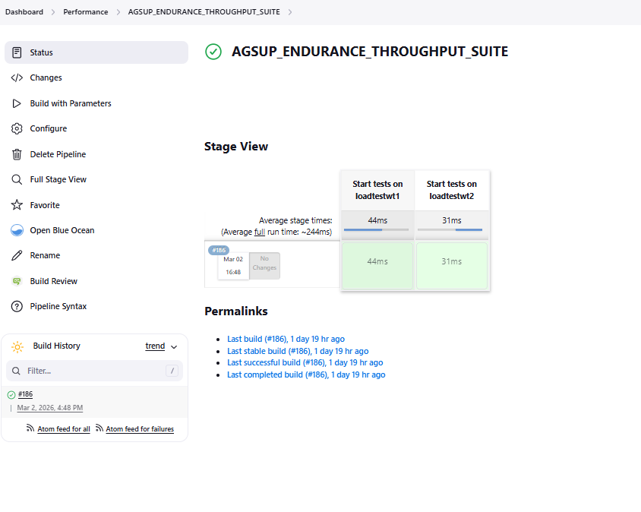
Build with Parameter:
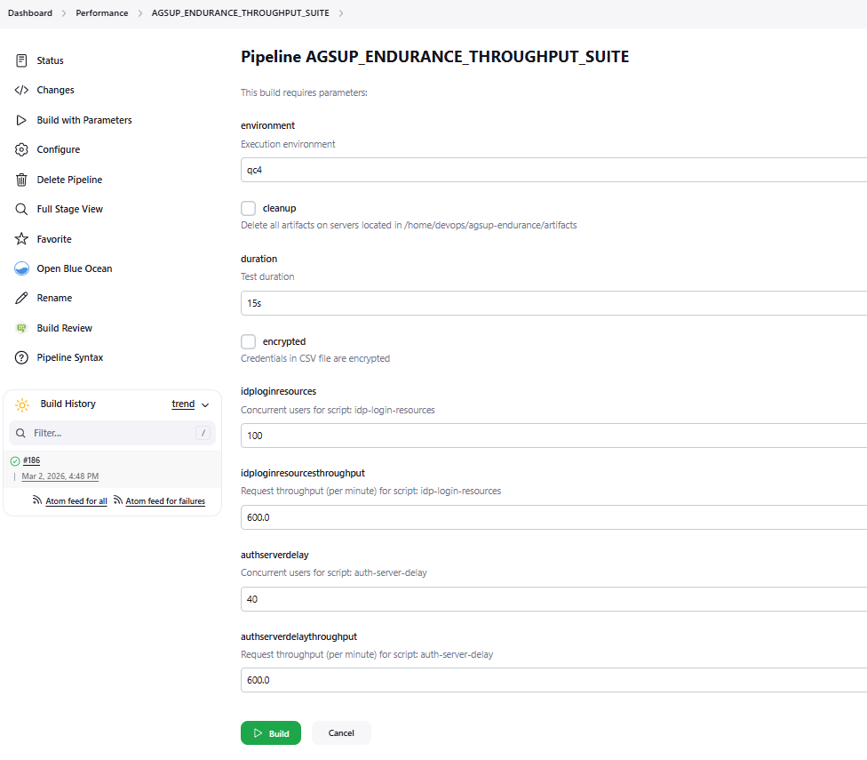

Config Details:
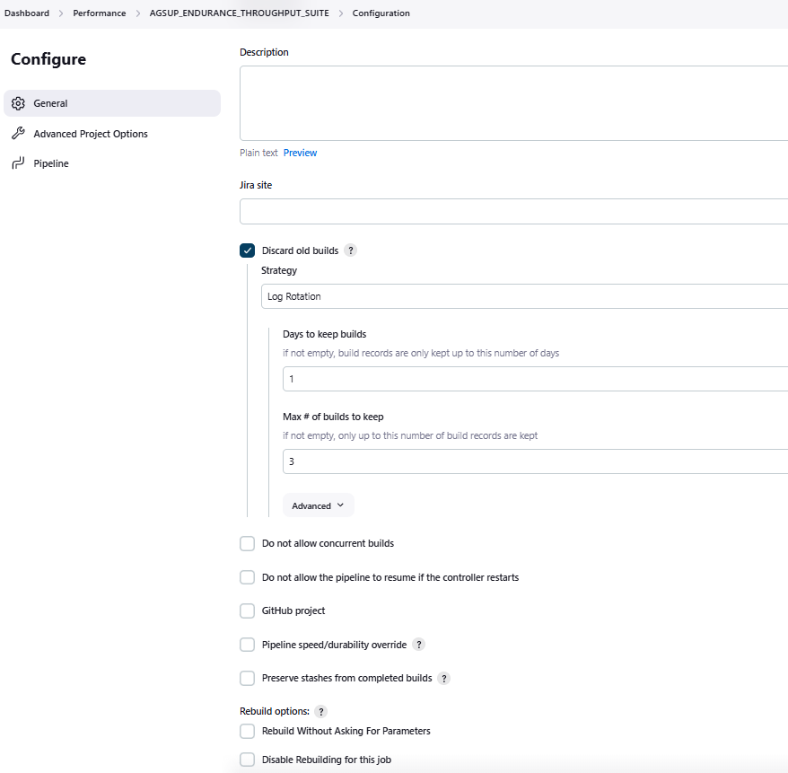
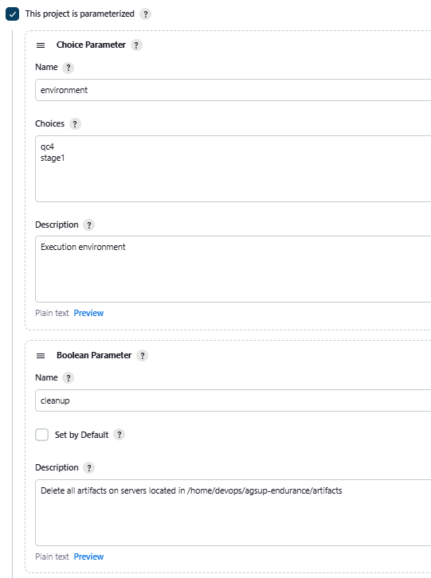
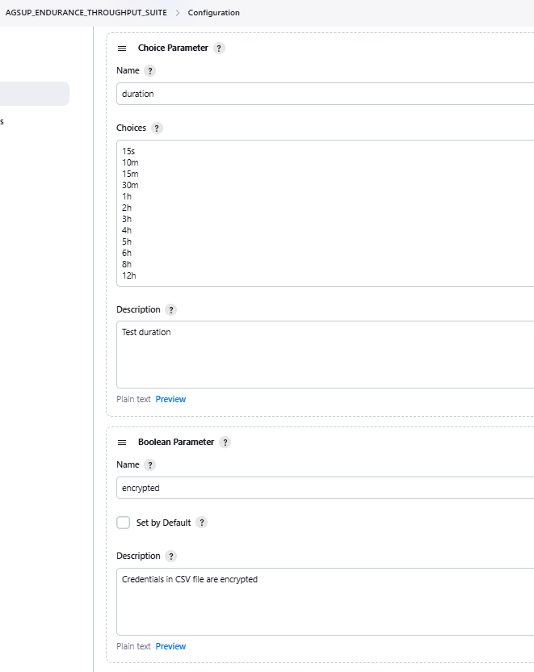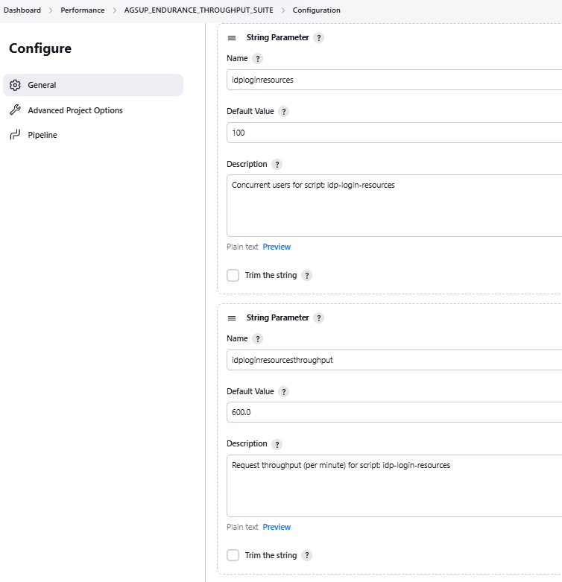
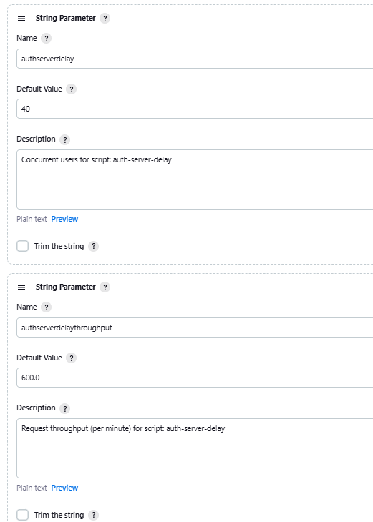

Pipeline:
def servers = ['loadtestwt1', 'loadtestwt2']

String server = servers[0];
stage("Start tests on ${server}") {
if (params.cleanup) {
build job: 'AGSUP_ENDURANCE_CLEANUP', parameters: [string(name: 'server', value: "${server}"), string(name: 'cleanup', value: "delete"), string(name: 'target_dir', value: "/bzt-configs/artifacts")], propagate: false, wait: true;
}

build job: 'AGSUP_ENDURANCE_THROUGHPUT', parameters: [string(name: 'server', value: "${server}"), string(name: 'yaml', value: "universal/idp/jmeter/idp-login-resources-remote.yaml"),
string(name: 'environment', value: "${environment}"), booleanParam(name: 'encrypted', value: "${encrypted}"), string(name: 'concurrency', value: "${idploginresources}"),
string(name: 'duration', value: "${duration}"), string(name: 'ramp', value: "45s"), string(name: 'throughput', value: "${idploginresourcesthroughput}")], propagate: false, wait: false;
}

server = servers[1];
stage("Start tests on ${server}") {
if (params.cleanup) {
build job: 'AGSUP_ENDURANCE_CLEANUP', parameters: [string(name: 'server', value: "${server}"), string(name: 'cleanup', value: "delete"), string(name: 'target_dir', value: "/bzt-configs/artifacts")], propagate: false, wait: true;
}

build job: 'AGSUP_ENDURANCE_THROUGHPUT', parameters: [string(name: 'server', value: "${server}"), string(name: 'yaml', value: "universal/idp/jmeter/auth-server-delay-remote.yaml"),
string(name: 'environment', value: "${environment}"), booleanParam(name: 'encrypted', value: "${encrypted}"), string(name: 'concurrency', value: "${authserverdelay}"),
string(name: 'duration', value: "${duration}"), string(name: 'ramp', value: "45s"), string(name: 'throughput', value: "${authserverdelaythroughput}")], propagate: false, wait: false;
}

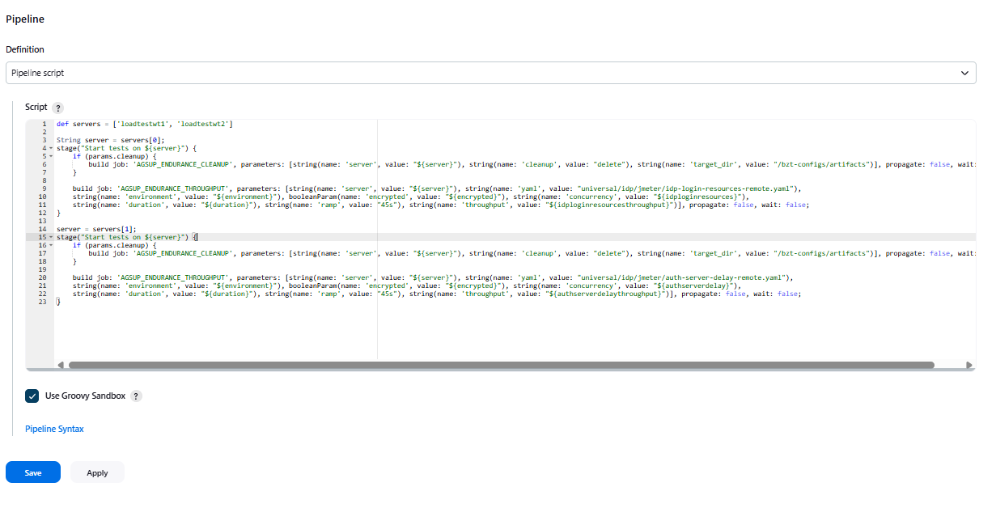

Job run details
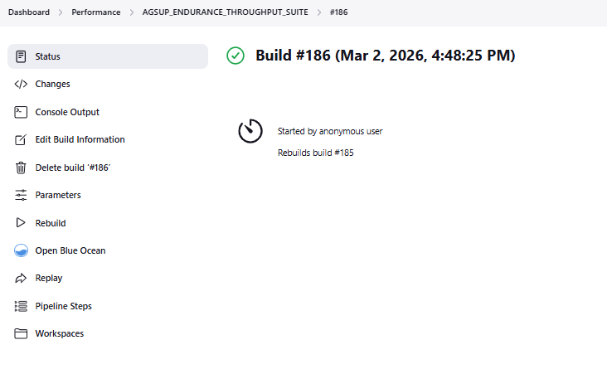

Console Output
Started by user unknown or anonymous
Rebuilds build #185
[Pipeline] Start of Pipeline
[Pipeline] stage
[Pipeline] { (Start tests on loadtestwt1)
[Pipeline] build (Building AGSUP_ENDURANCE_THROUGHPUT)
Scheduling project: AGSUP_ENDURANCE_THROUGHPUT
[Pipeline] }
[Pipeline] // stage
[Pipeline] stage
[Pipeline] { (Start tests on loadtestwt2)
[Pipeline] build (Building AGSUP_ENDURANCE_THROUGHPUT)
Scheduling project: AGSUP_ENDURANCE_THROUGHPUT
[Pipeline] }
[Pipeline] // stage
[Pipeline] End of Pipeline
Finished: SUCCESS

